Proceeding  International Conference on Economics, Business and Information Technology | E-ISSN 3025-4892  Vol. 6 (2025), Page XX-XX

Title (Max 20 words)
First Author¹, Second Author², Third Author³
¹ Department/Faculty, Affiliation, Country (Email)
² Department/Faculty, Affiliation, Country (Email)
³ Department/Faculty, Affiliation, Country (Email)

Abstract
The abstract should summarize the contents of the paper in short terms, i.e. 150-250 words. All submissions must include a structured abstract, following the format outlined below: Purpose, Research Methods, Findings, and Implication.
Keywords: (3-5 keywords)

1. Introduction
The introduction should describe the nature of the problem and current state of knowledge; state the purpose, scope and general methods, and present hypothesis and/or research goals. The paper should demonstrate an adequate understanding of the relevant literature in the field and cite an appropriate range of literature sources.
The introduction should state clearly the objective of the paper as well as the context of the investigation. The literature review should be limited to the articles, books and other items that are relevant to specific research questions addressed. The theoretical framework of the research may contain a full section explaining the motives of the research, identifying a gap in the existing literature of the research, and potential usefulness of the proposed theoretical basis.
2. Methods
The methods section describes the steps followed in the execution of the study and also provides a brief justification for the research methods used. It should contain enough detail to enable the reader to evaluate the appropriateness of your methods and the reliability and validity of your findings. Furthermore, the information should enable experienced researchers to replicate your study.
The methodology section contains the approach used in producing scientific articles. Specifically for scientific research articles, the methodology section includes research methods, populations, and samples, as well as data analysis steps.
3. Results and Discussion
The results of the study explain straightforwardly the research questions by using the results table of research data processing not only to describe the results of the research table but more directly than the analysis of the research results.
Discussion of the research part of the description of how the results of research which can be known whether it can be confirmed or unconfirmed so find answers to research questions of each variable / research hypothesis.
Display the table as below:

Table 1. ......
...... | ...... | ...... | ......
......
......
......
Source: explained

There are no vertical lines for the table. The table title is placed on top, middle. The source of the table is placed under the table.

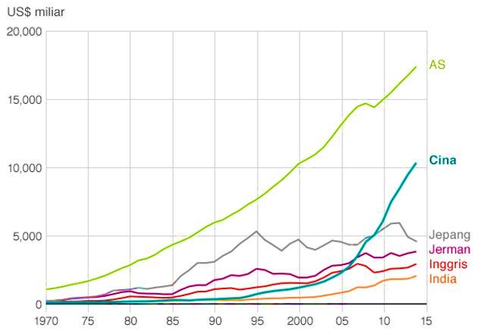
Figure 1. Picture Caption
Source: explained

The title of the image is placed at the bottom, middle. The source of the image is placed below the image.
4. Conclusion
Conclusions explain the findings of the study that are relevant to the research question and research objectives without using statistical data. The conclusion section includes the implications of further research and research.
References
Reference using American Psychological Association (APA) style 7 edition is recommended using Mendeley, EndNote and other reference applications (at least 80% of the primary literature).

